**1.Practice how to execute Bayesian updating, same as with class slides and HW1Do not need to memorize Bayes formula**

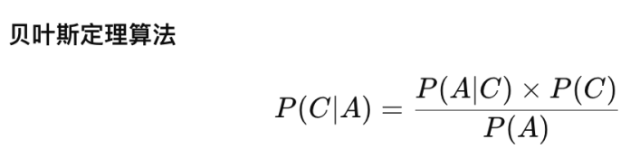，P(A|C)*P(C)=P(A)P(C)

**2.1Analytical solutions for mean, variance and covariance for linear combination of variables. Know how to convert covariance to correlation**

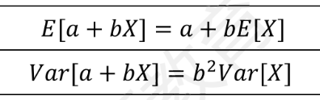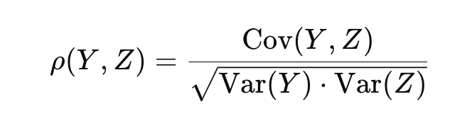

**2.2 What is unbiased/efficient estimator, and be able to determine if a basic estimator formula is either**

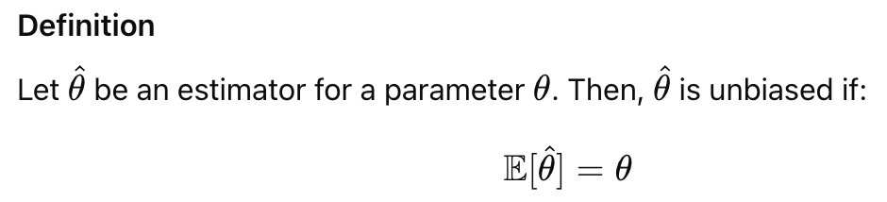

如果估计量有偏差，则意味着估计量的预期值与 true 参数之间存在差异，称为偏差。

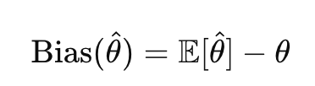

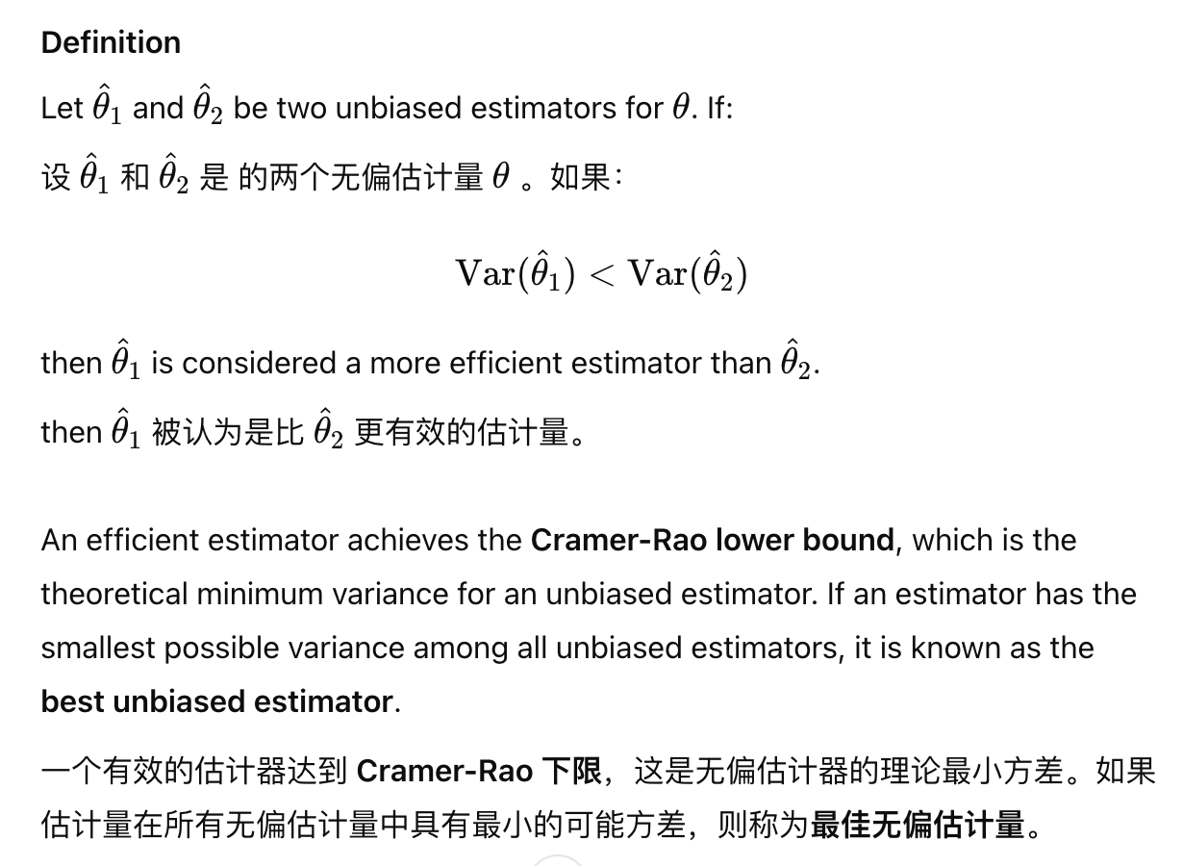

**2.3 Starting from PDF, derive CDF and Inverse CDF and work with these functions**

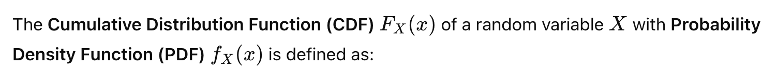

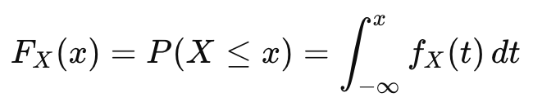

Steps to Derive the CDF from the PDF

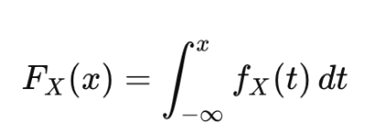

Steps to Derive the Inverse CDF from the CDF

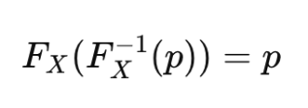

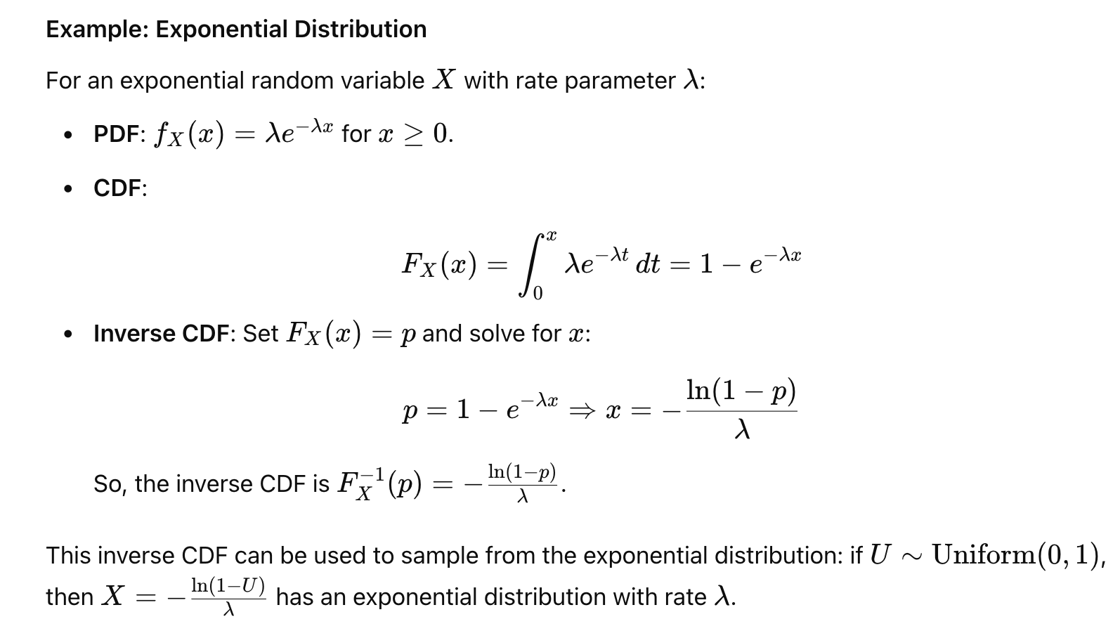

**2.4.Understand intuitively what high kurtosis and skew mean. No need to memorize formulas**

high skew :asymmetry 表示存在一些非常大的值

high kurtosis：tailedness. Leptokurtic （High Kurtosis）

**2.5.Know how to conduct simple hypothesis testing**

(1)Define Hypotheses

(2)Choose a Significance Level(α)

(3)Select the Test and Calculate the Test Statistic

**Z-test: for large samples (n > 30) or known population standard deviation.**

**t-test: for small samples (n ≤ 30) and unknown population standard deviation.**

**Chi-square test: for categorical data.卡方检验：用于分类数据。**

(4)Find the Critical Value or p-value

(5)Make a Decision: reject or accept

(6)Interpret the Results

**3.1 Be familiar with how distributions ‘convert’ or how they can combine with each other to get new distributions.Do not need to memorize any pdf or cdf formulas**

1.Linear Transformations of Random Variables

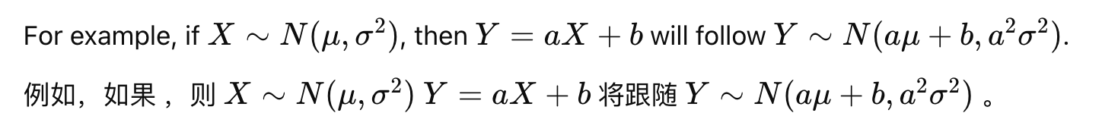

2.Sum of Independent Random Variables

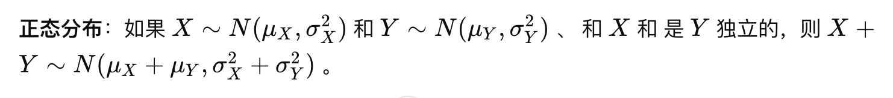

**3.2 Given the pdf or cdf formulas for some distributions, be able to derive mean and variance**

pdf：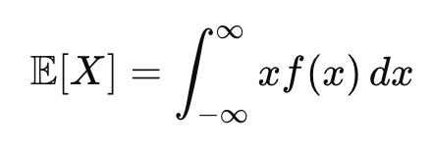

pmf：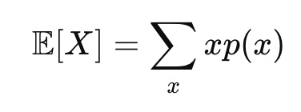

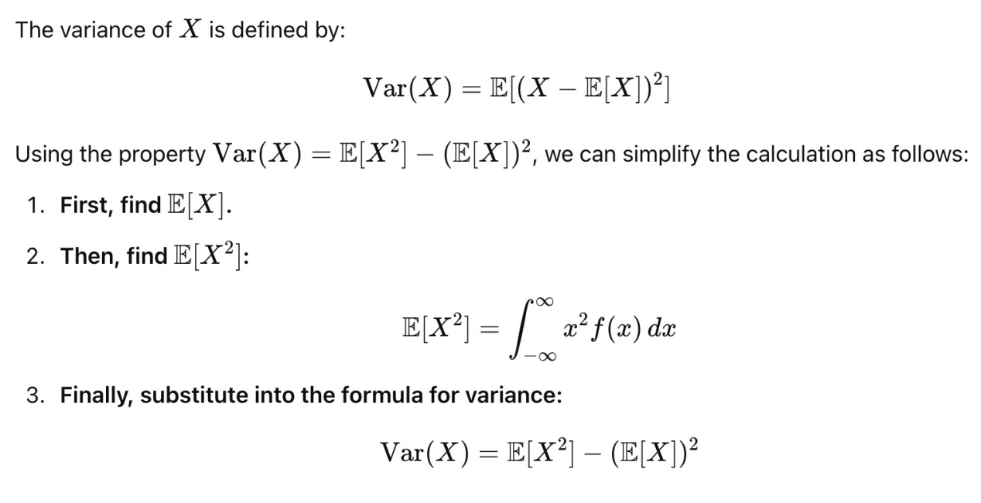

**3.3 Appreciate difference between stationary and covariance stationary**

Stationarity:

1. Constant Mean
2. Constant Variance
3. Constant Autocovariance

平稳时间序列是可预测的，因为它的行为不依赖于时间段，所有统计属性，包括偏度和峰度等较高矩，都是恒定的,因此更易于建模和分析。

Covariance Stationarity (Weak Stationarity):

1. Constant Mean

(2)Constant Variance

(3)Autocovariance Only Depends on Lag

协方差平稳性主要关注前两个矩（均值和方差）和自协方差，而不是所有统计属性。这使得它不如严格平稳性严格，严格平稳性要求分布的所有方面随着时间的推移保持不变。

**3.4 Recall what are conditions for OLS to be used**

(1)误差项ei的预期值（平均值）为零

(2)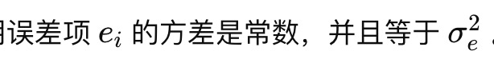

(3)对于任何一对观测值 和 j ，误差 ei和 ej都是不相关的。

(4)Xi​ 独立于 all i和 的 j误差项 ej

(5)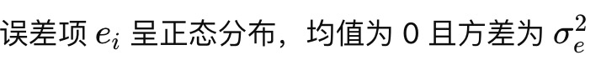

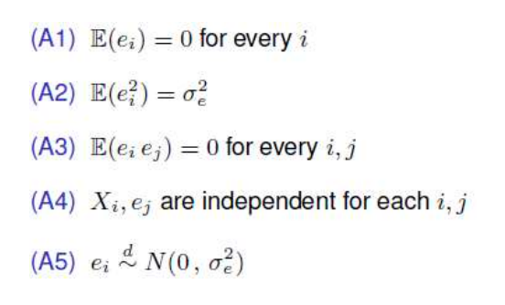

**3.5 Recall why we prefer to estimate models on covariance stationary data rather than variables which are not stationary**

1. Avoiding Spurious Regression1. 避免伪回归

2. Reliable and Consistent Parameter Estimates2. 可靠且一致的参数估计

3. Meaningful Inference and Hypothesis Testing3. 有意义的推理和假设检验

4. Predictive Accuracy and Stability4. 预测准确性和稳定性

5. Easier to Interpret Relationships5. 更容易解释关系

6. Avoiding Problems with Autocorrelation6. 避免自相关问题

**3.6 Be able to interpret Python print-outs of selected hypotheses tests, up to and including “what to do” following test results:i. Durbin Watson and BG test ii. GQ test OLS Preconditions3**

**4.1 Intuitively recall at a high level the implications of the Gauss Markov theorem**

**核心含义:**高斯-马尔可夫定理说明了在满足特定假设的前提下，使用最小二乘法（OLS） 估计回归系数是最优的。在以下条件满足时，OLS 估计量是所有线性无偏估计量中方差最小的，也就是具有“最佳线性无偏估计量”（Best Linear Unbiased Estimator, 简称 BLUE）性质：

**假设条件包括：线性关系、随机抽样、无完全多重共线性、误差的期望值为零、误差方差恒定（同方差性）、误差项之间无自相关。**

**最优线性无偏估计（BLUE）：**

在满足一定假设（如线性关系、随机抽样、无完全多重共线性、误差均值为零、误差方差恒定）的条件下，OLS 是最优的线性无偏估计。

B最优：在所有线性无偏估计中，OLS 的方差最小，也就是估计结果最精确。

L线性：OLS 是数据的线性组合。

U无偏：OLS 的期望值等于参数的真实值。

E高效性：

**4.2 Be able to interpret printouts of OLS regression results from Python, focusing on:**

**(1) R square / adjusted R square**

值越高（越接近 1）意味着拟合越好，这表明模型解释了因变量中的方差越多。例如， R2=0.8 表示因变量中 80% 的方差由预测变量解释。

A higher adjusted R-squared indicates a better model fit after accounting for model complexity.

**(2)Coefficient estimates and t-statistics**

Positive coefficients indicate a positive relationship between the predictor and the dependent variable,

If p-value < 0.05 (common threshold), the predictor is considered statistically significant.

**(3)F-statistic (for regression) and associated p values**

F-statistic: Tests whether the overall regression model is a good fit for the data.

Associated p-value: If the p-value for the F-statistic is low, it suggests the model is meaningful as a whole.

**(4)DW statistic**

Tests for autocorrelation in the residuals (errors).

**(5)JB stat and associated p values**

If the JB p-value > 0.05, there is no significant evidence against normality, and the residuals can be considered approximately normal.如果 JB p 值 > 为 0.05，则没有显著的正态证据，残差可以认为近似正态。

If the JB p-value ≤ 0.05, the residuals deviate significantly from normality, which could impact inference in small samples.如果 JB p 值≤ 0.05，则残差明显偏离正态性，这可能会影响小样本中的推理。

**(6)Skewness**

Skewness ≈ 0: The residuals are symmetrically distributed.偏度 ≈ 0：残差对称分布。

Positive skewness: The residuals have a long right tail.正偏度：残差具有较长的右尾。

Negative skewness: The residuals have a long left tail.负偏度：残差具有较长的左尾。

**(7)Kurtosis**

* **Kurtosis ≈ 3**: Normal kurtosis (for a normal distribution).**峰度 ≈ 3**：正态峰度（正态分布）。
* **Kurtosis > 3**: Leptokurtic (residuals have heavier tails, with more extreme values than a normal distribution).**峰度 > 3**： Leptokurtic（残差的尾部较重，比正态分布具有更多的极值）。
* **Kurtosis < 3**: Platykurtic (residuals have lighter tails, with fewer extreme values).**峰度 < 3**： 扁形（残差的尾部较轻，极值较少）。

**4.3 Memorize the CAPM equation, and appreciate how to estimate it using OLS**

**Qualitatively appreciate the differences between low and high beta stocks**

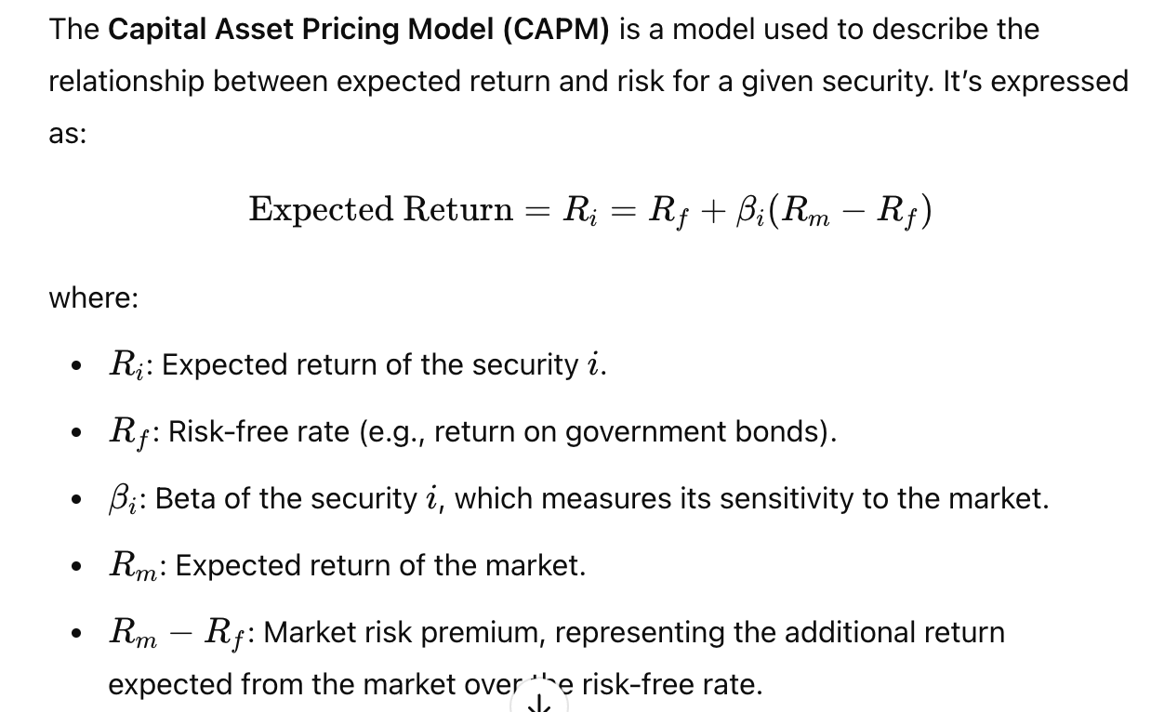

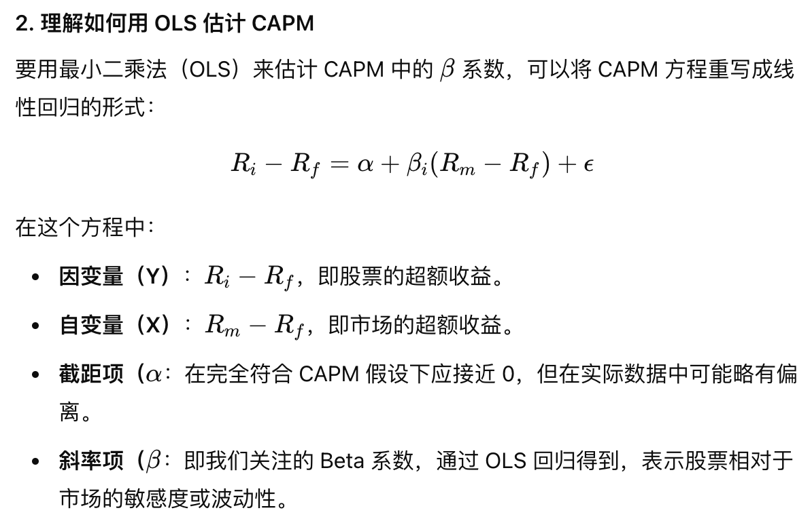

低 Beta 股票（β<1：

对市场波动的反应较小，波动性低于市场平均（日常消费品、公用事业等行业）

高 Beta 股票（β>1：

对市场波动反应更敏感，波动性高于市场平均。科技、消费类等行业，尤其是在经济周期波动中表现更为显著。

**4.4 Appreciate qualitatively what is autocorrelation Know how to mathematically compute autocorrelation for some simple data generating processes (i) AR(1) and (ii) MA(1)**

Autocorrelation, also known as serial correlation, measures the degree to which a time series is correlated with its own past values. 自相关（也称为序列相关）衡量时间序列与其自身过去值的相关程度。

Positive Autocorrelation: If there is positive autocorrelation, high values in the series tend to be followed by high values, and low values by low values.正自相关：如果存在正自相关，则序列中的高值往往后跟高值，低值后跟低值。

**AR(1)**

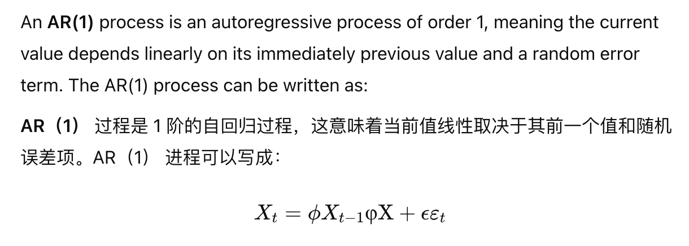

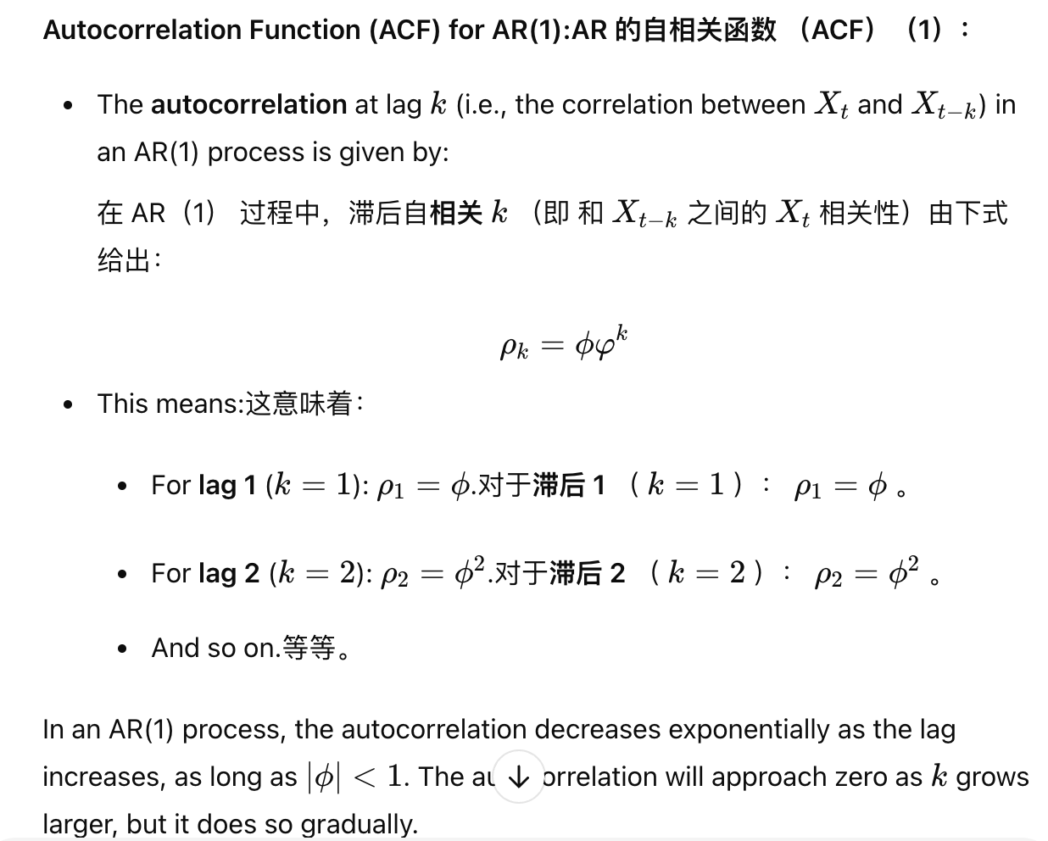

**MA(1)**



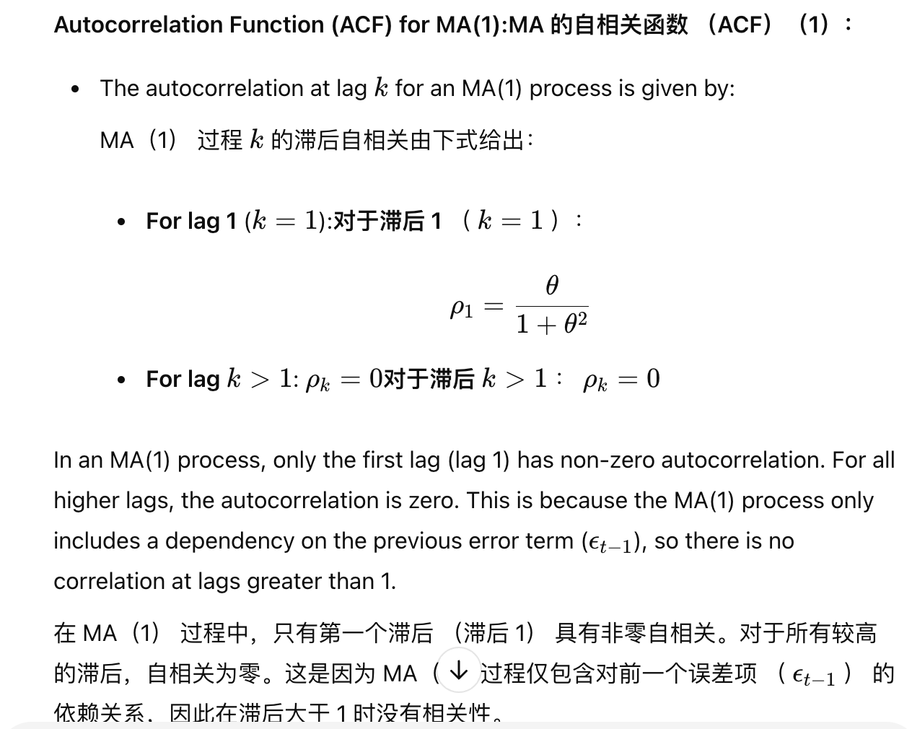

**4.5 Reasons for time series decomposition High level algorithm for classical TSdecomposition (role of moving averages, what the various components mean, how to tell if a seasonal pattern is important or not)**

**4.5.1时间序列分解的原因：**

**(1)Identify Patterns:** Decomposition helps separate and identify trend, seasonality, and residual (irregular) components. This allows us to see whether changes in the time series are due to long-term trends, recurring seasonal patterns, or random fluctuations.识别模式：分解有助于分离和识别趋势、季节性和残差（不规则）组件。这使我们能够查看时间序列的变化是由于长期趋势、反复出现的季节性模式还是随机波动。

**(2)Improved Forecasting**: By isolating different components, we can model each part individually, leading to more accurate forecasts. For instance, we can model the trend separately from seasonal effects and then combine them to predict future values.改进的预测：通过隔离不同的组件，我们可以单独对每个部分进行建模，从而获得更准确的预测。例如，我们可以将趋势与季节性效应分开建模，然后将它们结合起来预测未来值。

**(3)Detect Seasonality and Trend**: Decomposition can help determine if there is a strong seasonal pattern or a consistent trend in the data, which can inform business or policy decisions.检测季节性和趋势：分解可以帮助确定数据中是否存在强烈的季节性模式或一致的趋势，这可以为业务或政策决策提供信息。

**(4)Denoise the Data:** By separating out random noise, decomposition helps reduce noise in the series, making it easier to detect significant patterns and changes over time.对数据进行降噪：通过分离出随机噪声，分解有助于减少序列中的噪声，从而更容易检测随时间变化的重要模式和变化。

**4.5.2经典时间序列分解算法的概述**

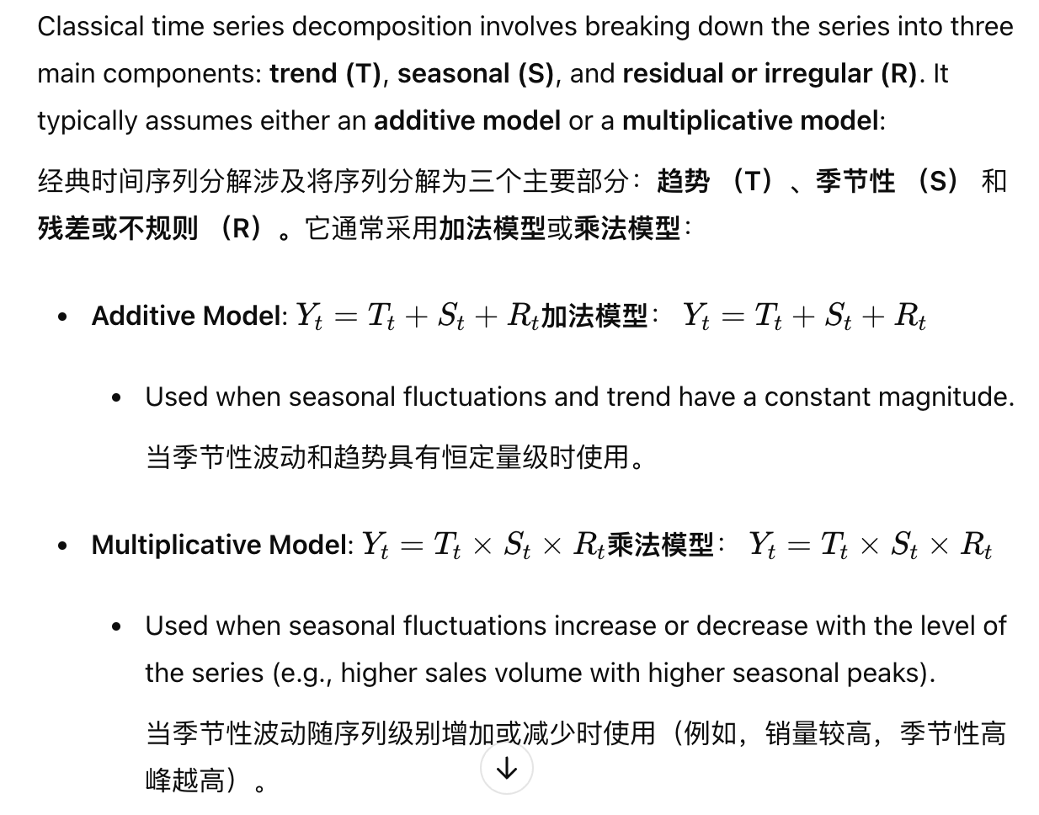

#### **4.5.3 经典时间序列分解的步骤**

**(1)计算 Trend Component**：

* 1. The trend component captures the long-term increase or decrease in the series.趋势分量捕获序列中的长期增加或减少。
  2. **Role of Moving Averages**: Moving averages (often centered moving averages) are typically used to estimate the trend by smoothing the data over a window (e.g., 12 months for yearly data).**移动平均线的作用**：移动平均线（通常是居中移动平均线）通常用于通过在窗口（例如，年度数据为 12 个月）内平滑数据来估计趋势。
  3. The moving average helps to “smooth out” short-term fluctuations, allowing the underlying trend to become visible.移动平均线有助于“平滑”短期波动，使潜在趋势变得可见。

**(2)删除提取季节性分量和残差分量的趋势**：

* 1. Subtract (or divide, in the case of multiplicative decomposition) the trend from the original series to isolate the seasonal and residual components.从原始序列中减去（或除以，在乘法分解的情况下）趋势，以隔离季节性分量和残差分量。
  2. This “detrending” step allows us to focus on the repeating seasonal pattern and any remaining irregularities.这个 “detrending” 步骤使我们能够专注于重复的季节性模式和任何剩余的不规则性。

**(3)估计Seasonal Component**:：

* 1. The seasonal component represents recurring patterns within each period (e.g., monthly or quarterly).季节性分量表示每个时期（例如，每月或每季度）的重复模式。
  2. Calculate the **average value for each season** (e.g., for each month or quarter) across multiple periods to estimate the seasonal component.计算多个期间**每个季节（**例如，每个月或每个季度）的平均值，以估计季节性分量。
  3. For instance, for monthly data, you would calculate the average deviation of each month from the trend to determine a seasonal index for each month.例如，对于月度数据，您将计算每个月的平均值与趋势的偏差，以确定每个月的季节性指数。

**(4)提取Residual Component**

* 1. After removing both the trend and seasonal components, the remainder is the residual (or irregular) component.在删除趋势分量和季节性分量后，余数是残差（或不规则）分量。
  2. The residuals capture random noise and irregular fluctuations that are not explained by the trend or seasonality.残差捕获了无法用趋势或季节性解释的随机噪声和不规则波动。

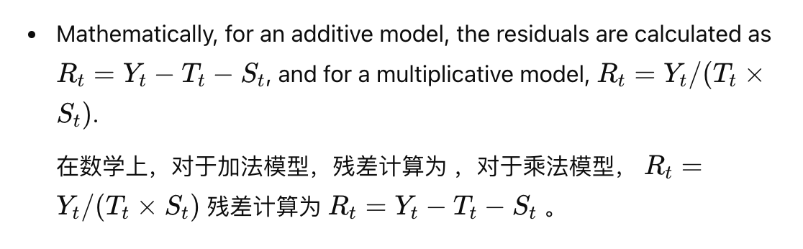

### 4.5.4Determining the Importance of a Seasonal Pattern确定季节性模式的重要性：

**(1)Visual Inspection**: Plot the seasonal component alone and observe if there are clear, regular patterns. Significant and consistent peaks and troughs suggest that seasonality is important.**目视检查**：单独绘制季节性成分，并观察是否有清晰、规则的模式。显著且一致的高峰和低谷表明季节性很重要。

**(2)Compare Variance**: Quantitatively, calculate the variance of the seasonal component and compare it to the total variance of the series. A high variance in the seasonal component relative to the total variance indicates that seasonality is important.**比较方差**：定量地计算季节性分量的方差，并将其与序列的总方差进行比较。季节性分量相对于总方差的高方差表明季节性很重要。

**(3)Residual Analysis**: After removing the trend and seasonal components, examine the residuals. If the residuals are relatively small and lack a pattern, it suggests that the seasonal and trend components explain most of the variation in the data.**残差分析**：删除趋势和季节性分量后，检查残差。如果残差相对较小且缺少模式，则表明季节性分量和趋势分量解释了数据中的大部分变化。

**(4)Statistical Tests**: For more rigorous analysis, statistical tests (e.g., autocorrelation of residuals, seasonal decomposition tests) can be used to confirm the presence of seasonality.**统计检验**：对于更严格的分析，可以使用统计检验（例如，残差的自相关、季节性分解检验）来确认季节性的存在。

**5.1 Interpret printouts of ndiffs, nsdiffs and KPSS test from R. Order of ndiffs and nsdiffs**

（1） ndiffs()

Purpose: ndiffs() estimates the number of regular differences needed to make a time series stationary (removing trend).目的：ndiffs（） 估计使时间序列平稳（去除趋势）所需的规则差值的数量。

输出是一个整数，表示差分的顺序（即应应用差分的次数）。

（2） nsdiffs()

Purpose: nsdiffs() estimates the number of seasonal differences needed to make the time series stationary with respect to seasonality.目的：nsdiffs（） 估计使时间序列相对于季节性保持平稳所需的季节性差异数。

与 ndiffs（）一样

（3） KPSS 测试 （Kwiatkowski-Phillips-Schmidt-Shin）

Purpose: The KPSS test is used to assess if a series is stationary around a mean (level) or around a trend.目的：KPSS 检验用于评估序列是静止在平均值（水平）附近还是围绕趋势静止。

Null Hypothesis (H0): The time series is stationary.原假设 （H0）：时间序列是平稳的。

Alternative Hypothesis (H1): The time series is not stationary (contains a unit root).备择假设 （H1）：时间序列不是平稳的（包含一个单位根）。

**在 R 中解释 KPSS 测试输出：**

（1）ndiffs 的结果

如果 ndiffs 的输出为 1，则表示需要对时间序列进行一阶差分。

如果为 0，说明不需要差分，因为数据已经平稳。

（2）nsdiffs 的结果：

如果 nsdiffs 的输出为 1，则表示需要进行一次季节性差分（适用于有季节性的数据）。

如果输出为 0，说明数据没有明显的季节性模式，不需要季节性差分。

（3）KPSS 测试结果：

如果 KPSS 测试的 p 值大于 0.05，则数据可能已经平稳，不需要进一步差分。

如果 p 值小于 0.05，表明数据非平稳，通常先进行一阶差分，然后再测试是否平稳。

**5.2 Conceptually appreciate sources of deterministic variation, such as number of days in a month, inflation, population, etc Purpose and use of Box-Cox**

确定性变化是指时间序列中可预测的系统模式或影响。与随机或随机变化不同，确定性变化是由可识别的外部因素引起的。

一个月的天数：某些月份（如 2 月）的天数比其他月份少，这可能会影响月度指标，尤其是在日常活动水平较高的行业（例如零售额）。

通货膨胀：通货膨胀会导致一般价格水平随着时间的推移而上涨，从而影响销售收入或工资等货币价值。

人口：对于随人口增长的指标（例如，零售总额），考虑人口变化（例如，使用人均值）有助于区分实际趋势与仅由于人口基数较大或较小而引起的变化。

**Purpose and Use of Box-Cox Transformation：**

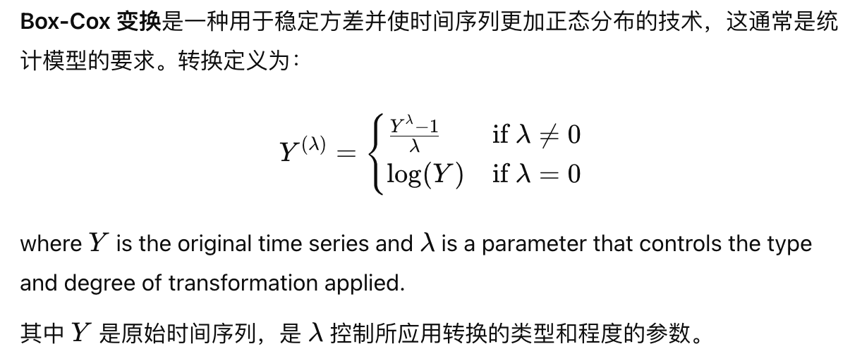

**Box-Cox 变换的目的**

1.稳定方差 （Stabilize Variance）：

Many time series exhibit variance that changes over time (heteroscedasticity). For example, financial data often show higher variance as values increase.许多时间序列表现出随时间变化的方差（异方差性）。例如，随着值的增加，财务数据通常显示更高的方差。

Applying Box-Cox can help transform the series to have more consistent variance, making it easier to model.应用 Box-Cox 可以帮助转换序列以使其具有更一致的方差，从而更容易建模。

2.Make Data More Normally Distributed:使数据分布更均匀：

Many forecasting and statistical techniques assume that the residuals (errors) are normally distributed.许多预测和统计技术都假设残差（误差）呈正态分布。

By using the Box-Cox transformation, we can reduce skewness, making the data more normally distributed and improving model accuracy.通过使用 Box-Cox 变换，我们可以减少偏度，使数据分布更均匀，并提高模型准确性。

3.Improve Model Fit:提高模型拟合度：

Stabilizing variance and normalizing data distribution often results in better-fitting models and more reliable forecasts, particularly in linear modeling and regression.稳定方差和规范化数据分布通常会产生更好的拟合模型和更可靠的预测，尤其是在线性建模和回归中。

Choosing the

𝜆

**5.3 Interpret out of sample python output of RMSE and MAPE for model selection.Formulas will be given**

1. RMSE (Root Mean Squared Error)

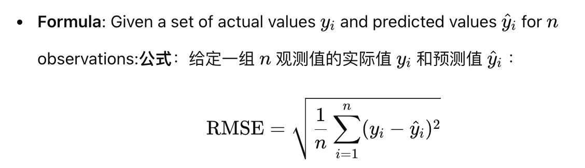

RMSE 表示以数据的原始单位表示预测误差的平均幅度。

RMSE 较低的模型通常表示更好的预测性能。

RMSE 对较大的误差很敏感，因此高 RMSE 可能意味着模型偶尔会与实际值有较大的偏差。

当重点是最小化总体误差幅度时，尤其是在特别不希望出现大误差的情况下，使用 RMSE 来比较模型。

2.MAPE (Mean Absolute Percentage Error)

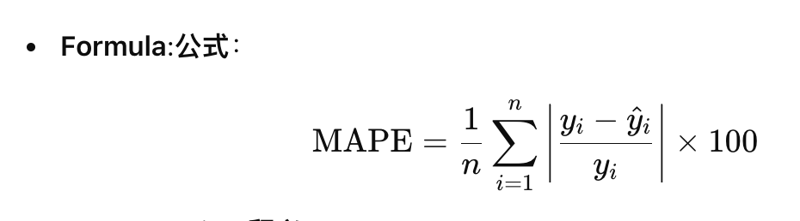

MAPE 将预测误差表示为实际值的百分比，使其成为与刻度无关的度量。

MAPE 越低表示模型性能越好，平均百分比误差越小。

MAPE 对于从相对角度了解模型准确性非常有用，因为它告诉您每个预测的平均误差百分比

**如何选择：**

1. 不同的误差视角：RMSE 以原始单位提供绝对误差，而 MAPE 以百分比表示相对误差。
2. 平衡绝对准确度（RMSE） ，平衡百分比准确度（MAPE）。

**6.1 Form reasonable hypotheses of ARIMA p,d,q order based on ACF and PACF.For ambiguous situations, ‘reasonable’ answers will be fine, but severe grade penalty for ‘obviously wrong’ suggestions**

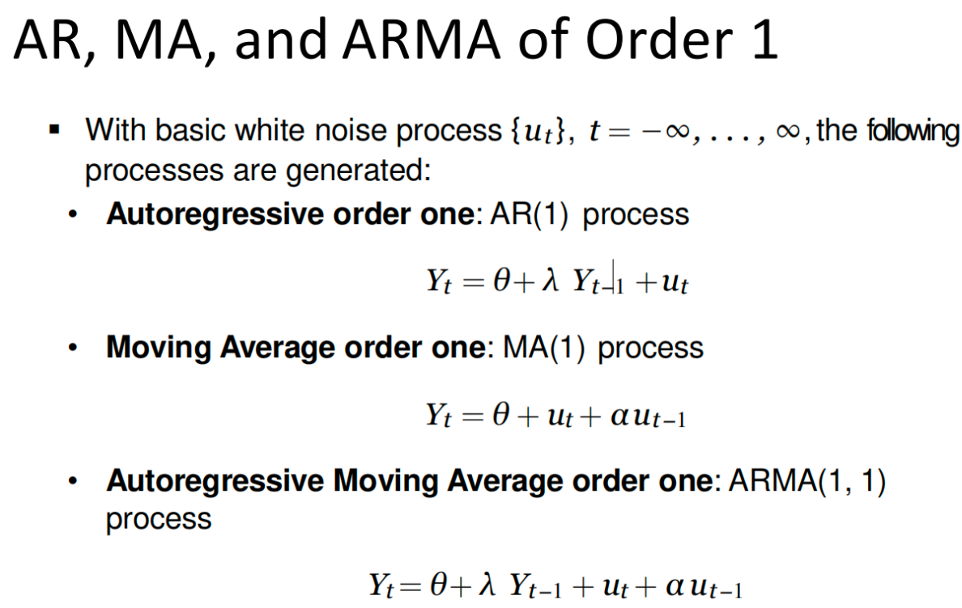

1. 检查序列的平稳性.Differencing Order **d**

如果序列是非平稳的（ACF 不会衰减到零），则从d=1开始并检查差分一次是否使序列平稳。如果没有，尝试 d=2 。

如果序列已经静止（ACF 和 PACF 快速衰减），d=0

1. Autoregressive Order **p**,Use the PACF plot.

Cutoff in the PACF at a certain lag：如果 PACF 在滞后后截断k，则p≈k

Decay in the ACF：

3.Moving Average Order **q**: Use the ACF plot.

Cutoff in the PACF at a certain lag：如果 ACF 在滞后m后截止，则q≈m

Decay in the ACF：

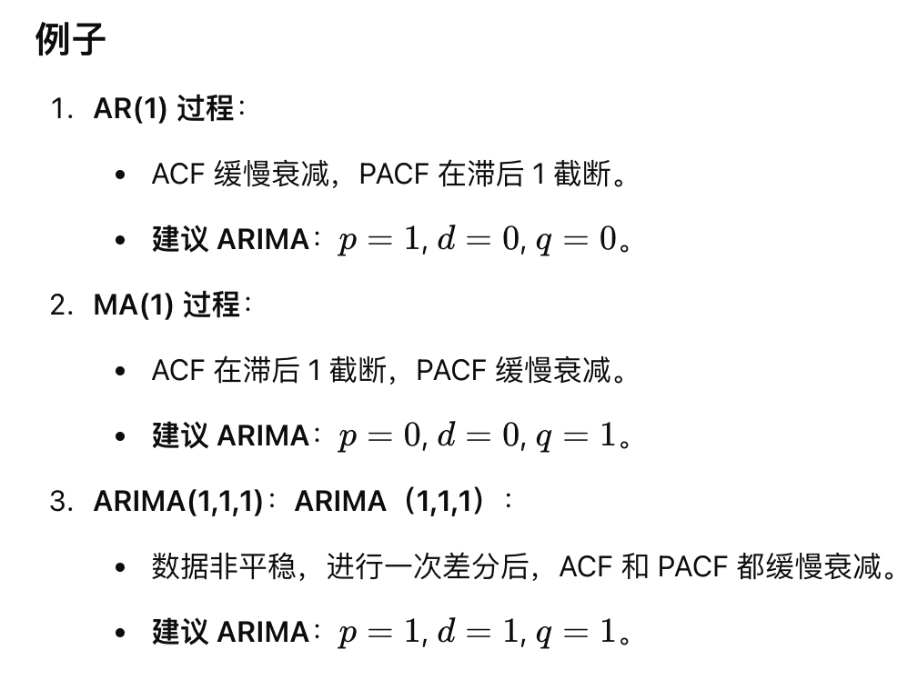

**6.2 Practice how to calculate the mean and variance of AR, MA and ARMA models of low order, e.g. 1,1,. Basic formula will be given, although not all terms in the formula may be elaborated on in the exam**

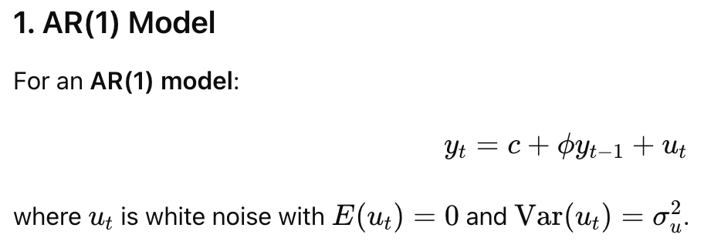

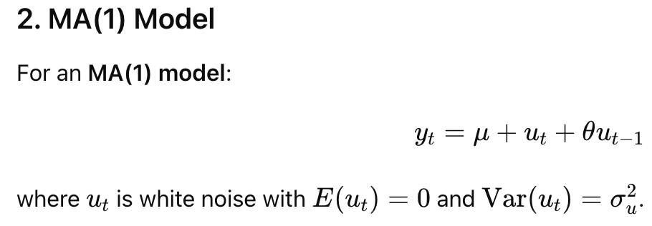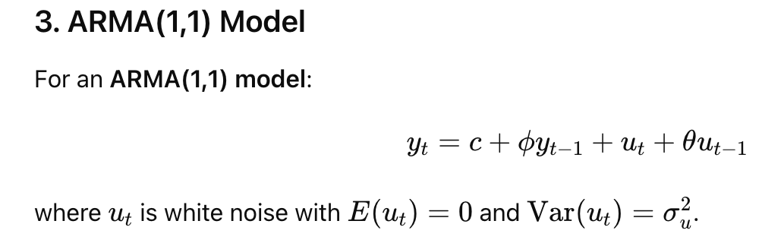

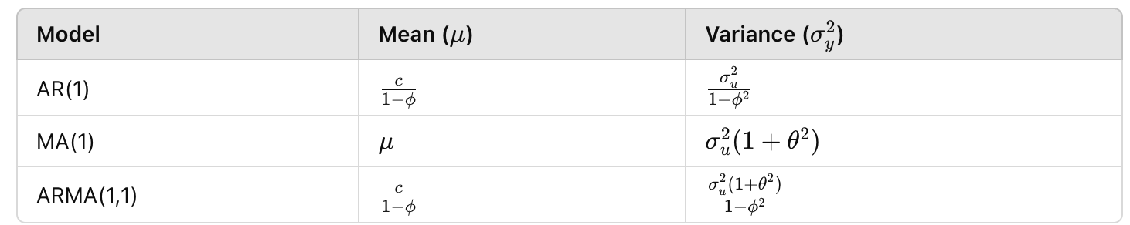

**6.3 Appreciate simple conditions on when an AR model is stationary, when an MA model is stationary (always!) and when ARMA is stationary – focus will be on low order models**

1. AR

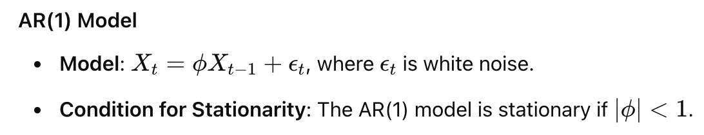

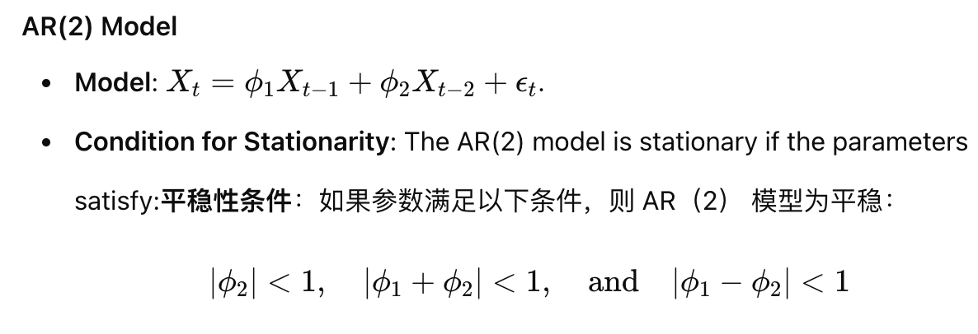

1. MR

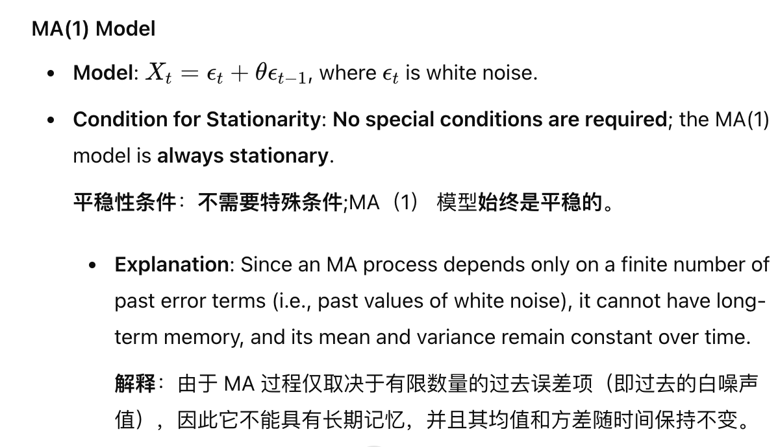

MR(2)同理

（3）ARIMA

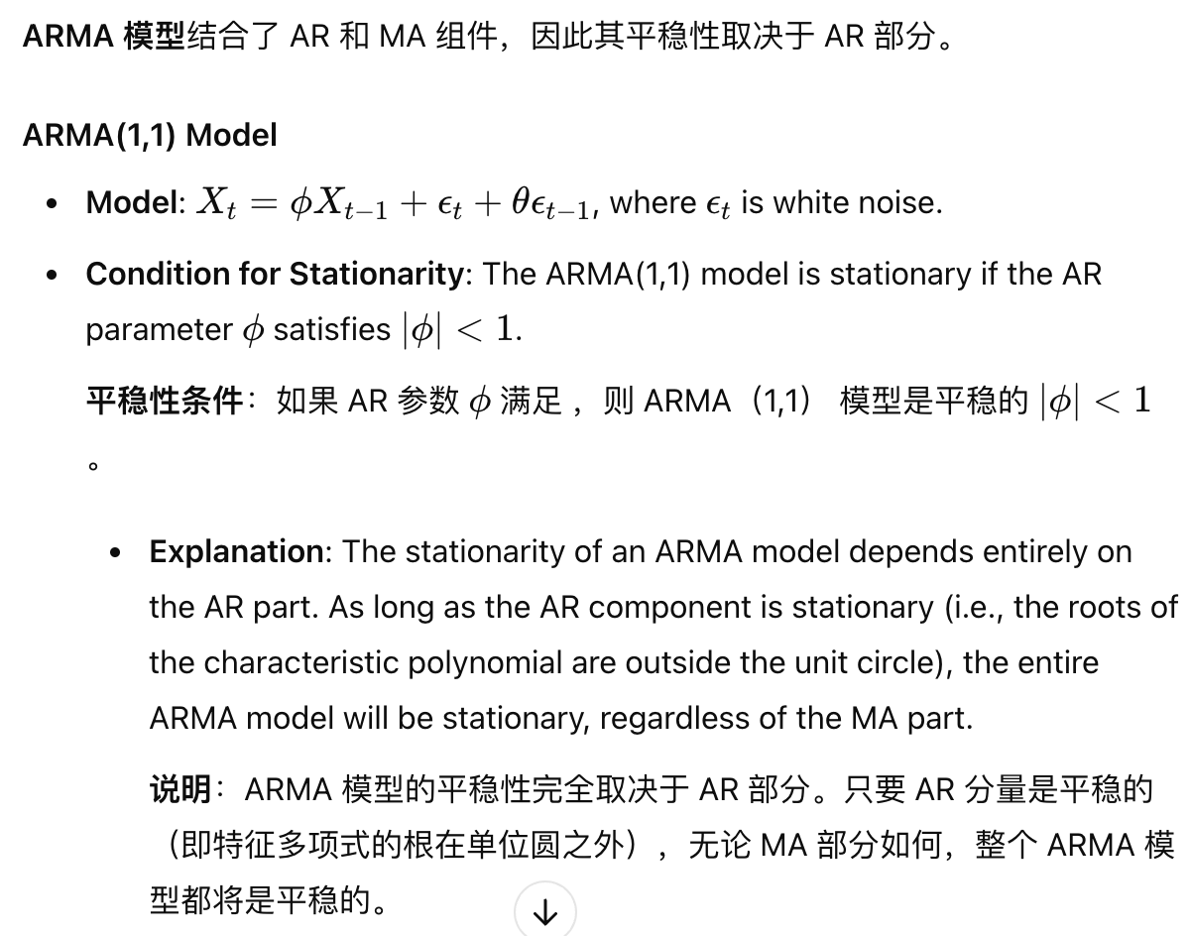

Higher-Order ARMA Models:平稳性条件与 AR（p） 模型相似

**6.4 Form hypotheses of p,d,q,P,D,Q based on ACF and PACF**

1. 确定 d 和 D（差分次数和季节性差分次数）

非季节性差分 d：如果 ACF 显示出缓慢衰减或显著非零的滞后值，说明序列非平稳，可能需要差分。先尝试一阶差分

季节性差分 D：如果 ACF 在季节性滞后（如 12 个月或 4 个季度）有明显的波动或峰值，考虑进行一次季节性差分（D=1）。

2. 确定 p和P（自回归项阶数和季节性自回归）

p AR 模型特征：如果 PACF 在滞后 1 处截断，则p=1；如果在滞后 2 处截断，则p=2。

3. 确定q和Q（移动平均项阶数和季节性移动平均项阶数）

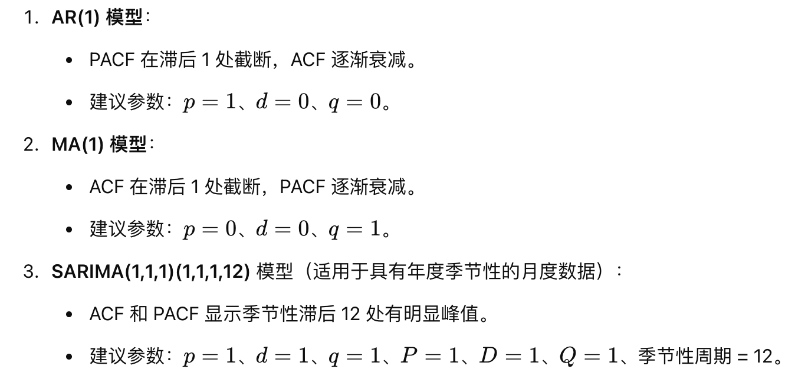

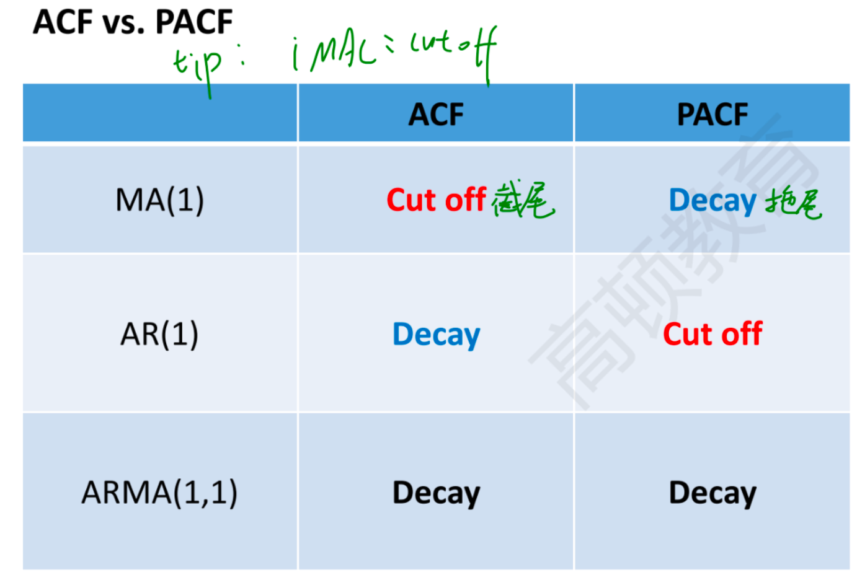

6.5 Understand how to tell from ACF when a time series has a long term trend and requires differencing (either seasonal or non seasonal)

（1）Non-Seasonal Differencing:非季节性差分：

If the ACF decays slowly and remains highly positive even at large lags, this indicates a long-term trend or non-stationarity.如果 ACF 缓慢衰减，即使在较大的滞后下也保持高度正值，则表明存在长期趋势或非平稳性。

A slow decay suggests the series has a persistent pattern, and non-seasonal differencing (taking the first difference) may be needed to remove the trend and achieve stationarity.缓慢衰减表明序列具有持续模式，可能需要非季节性差分（取第一个差值）来消除趋势并实现平稳性。

（2）Seasonal Differencing:季节性差分：

If the ACF shows spikes at seasonal lags (e.g., every 12 lags for monthly data) and the pattern repeats, this suggests a seasonal trend.如果 ACF 在季节性滞后处显示峰值（例如，月度数据每 12 个滞后一次）并且该模式重复，则表明存在季节性趋势。

In this case, seasonal differencing (subtracting the value from the same period in the previous season) may be required to remove the seasonal pattern.在这种情况下，可能需要季节性差分（减去上一季节同期的值）来删除季节性模式。

**6.6Conceptual understanding on difference between 1st and 2nd stage errors Applications of ARIMA-X**

第一阶段误差：指模型在拟合历史数据时的误差。它通常表示模型对历史数据的拟合质量，比如参数选择不当、遗漏了某些趋势等问题，都会导致第一阶段误差较大。

第二阶段误差：指模型在预测未来值时的误差。即使模型在第一阶段拟合得很好，未来不可预见的事件（比如市场突然波动）也可能导致第二阶段的预测误差较大。

ARIMA-X（带外生变量的ARIMA模型）应用：

ARIMA-X 是 ARIMA 模型的扩展版本，带有外生变量（exogenous variables）。与基本的 ARIMA 模型不同，ARIMA-X 模型可以包含额外的外部因素，这些因素不属于时间序列本身，但可能影响序列的未来值。

应用场景：在经济预测中，可以加入利率或通货膨胀率等外生变量；在需求预测中，可以加入促销活动或天气因素；在能源负荷预测中，可以加入温度等因素。

**6.7Model selection criteria (AICc) and high level understanding of automated model selection [i.e. how does auto.arima work on the**

**backend]**

AICc用于评估和比较不同时间序列模型的拟合优度，尤其是在样本量较小的情况下。

较低的 AICc 值表示模型拟合越好

auto.arima 通过以下方式自动选择 ARIMA 模型：

（1）Testing combinations of ARIMA parameters to find the lowest AICc,测试 ARIMA 参数的组合以找到最低的 AICc，

（2）Automatically selecting differencing orders,自动选择差分阶数，

（3）Using stepwise search for efficiency,使用逐步搜索提高效率，

（4）Validating model assumptions to ensure reliability.验证模型假设以确保可靠性。

**7.1 Purpose of VAR**

capture the interdependencies and dynamic relationships among multiple time series variables.向量自回归 （VAR） 模型的目的是捕获多个时间序列变量之间的相互依赖关系和动态关系。

Forecasting: VAR models are used to forecast multiple time series simultaneously by leveraging relationships among them.预测：VAR 模型用于通过利用它们之间的关系同时预测多个时间序列。

Impact Analysis: They help analyze how shocks in one variable impact others over time, useful in economic and financial systems.影响分析：它们有助于分析一个变量的冲击如何随着时间的推移影响其他变量，在经济和金融系统中非常有用。

Granger Causality Testing: VAR can test causal relationships to see if past values of one variable improve forecasts of another.格兰杰因果关系检验：VAR 可以检验因果关系，以查看一个变量的过去值是否改善了对另一个变量的预测。

**7.2 State a VAR of order p with k dependent variables in equation form, and conditions on variables**

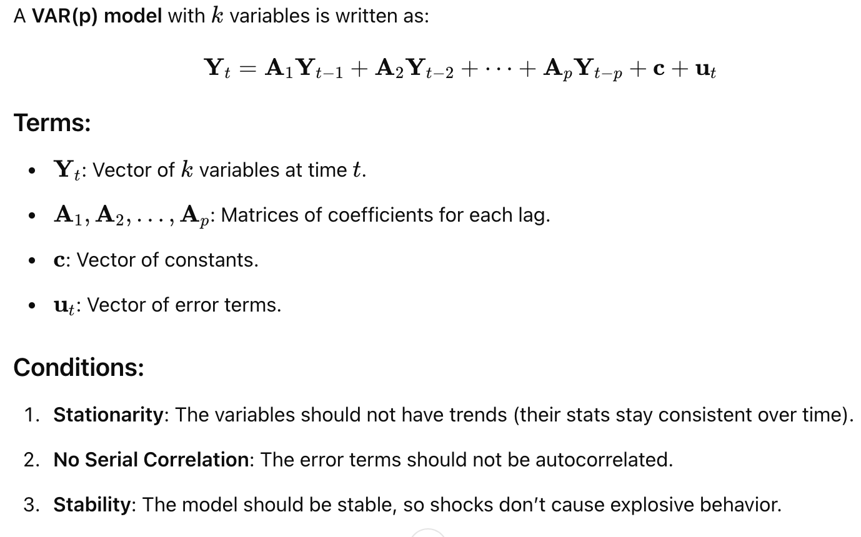

**7.3 Model selection process and criteria**

**Steps in Model Selection**

（1）Define Candidate Models: Choose different models based on theory, past studies, or a range of parameters.

（2）Estimate Models: Fit each candidate model to the data.

（3）Evaluate Model Fit: Use selection criteria to evaluate each model’s performance.

**Common Model Selection Criteria**

（1）Akaike Information Criterion (AIC):

Formula: AIC=2k−2ln(L)

Purpose: Penalizes complexity (number of parameters k) and rewards goodness of fit (likelihood L).

Goal: Minimize AIC

（2）Bayesian Information Criterion (BIC):

Formula: BIC=kln(n)−2ln(L)

Purpose: Like AIC, but penalizes complexity more heavily with larger sample sizes n.

Goal: Minimize BIC.

（3）Cross-Validation (e.g., K-fold):

Process: Split data into K parts, train the model on K−1 parts, and test on the remaining part, repeating K times.

Goal: Minimize average prediction error across all folds.

（4）Adjusted R-squared (for linear regression):

Adjusts R-squared by penalizing for additional predictors that don’t improve fit significantly.

Goal: Maximize Adjusted R-squared while avoiding unnecessary complexity.

**7.4 Purpose of VECM and conditions under which VECM can be used**

（1）Model Long-Term Equilibrium: VECM accounts for the cointegrating relationship among variables, ensuring that any deviations from the long-term equilibrium are corrected over time.模型长期均衡：VECM 考虑了变量之间的协整关系，确保随着时间的推移，任何与长期均衡的偏差都会得到纠正。

（2）Capture Short-Term Dynamics: It includes short-term changes, allowing the model to respond to immediate shocks while maintaining long-term stability.捕获短期动态：它包括短期变化，使模型能够响应即时冲击，同时保持长期稳定性。

（3）Forecasting: VECM provides better forecasts for cointegrated series by incorporating both long-term and short-term behavior.预测：VECM 通过结合长期和短期行为，为协整序列提供更好的预测。

**使用条件**

（1）Non-Stationary Series: The time series should be non-stationary in levels but stationary in their differences (i.e., they are integrated of the same order

时间序列在水平上应该是非平稳的，但在它们的差异上应该是平稳的（即，它们通常 以相同的顺序积分）。

（2）Cointegration: The variables must be cointegrated, meaning they have a stable, long-term relationship despite being individually non-stationary. Cointegration tests (like the Johansen test) confirm this relationship.协整：变量必须协整，这意味着尽管它们单独不稳定，但它们具有稳定的长期关系。协整检验（如 Johansen 检验）证实了这种关系。

（3）Multiple Time Series: VECM is suitable for multivariate time series data where we want to analyze the interactions among variables.多时间序列：VECM 适用于多变量时间序列数据，我们希望在其中分析变量之间的交互作用。

**7.5 Economic intuition behind error correction term**

The economic intuition behind the error correction term is that it represents the pull back to long-term equilibrium after a short-term deviation, ensuring that related variables (like prices and demand) adjust over time to maintain a stable relationship.纠错项背后的经济直觉是，它表示在短期偏差后回落到长期均衡，确保相关变量（如价格和需求）随着时间的推移进行调整以保持稳定的关系。

**7.6 Order selection process for VECM [same as VAR]**

（1）Fit Models with Different Lags: Estimate VECM models with varying lag lengths.拟合具有不同滞后的模型：估计具有不同滞后长度的 VECM 模型。

（2）Use Information Criteria:使用信息标准：

Akaike Information Criterion (AIC), Bayesian Information Criterion (BIC), and Hannan-Quinn Criterion (HQ) help compare models.Akaike 信息准则 （AIC）、贝叶斯信息准则 （BIC） 和 Hannan-Quinn 准则 （HQ） 有助于比较模型。

Lower values indicate a better fit relative to complexity.较低的值表示相对于复杂性的拟合度越好。

（3）Check for Autocorrelation: Ensure that residuals have no autocorrelation at the selected lag, as residual autocorrelation suggests underfitting.检查自相关：确保残差在所选滞后处没有自相关，因为残差自相关表明欠拟合。

（4）Final Selection: Choose the lag order with the best balance of fit and simplicity, typically indicated by the lowest information criterion values and no residual autocorrelation.最终选择：选择在拟合和简单性之间具有最佳平衡的滞后顺序，通常由最低信息标准值表示，并且没有残差自相关。

**7.7 Mathematical intuition of similarity of GARCH to ARIMA-X modelling**

这两个模型都包含Autoregressive (AR) and Moving Average (MA) Terms:

Recursive Structure:递归结构：

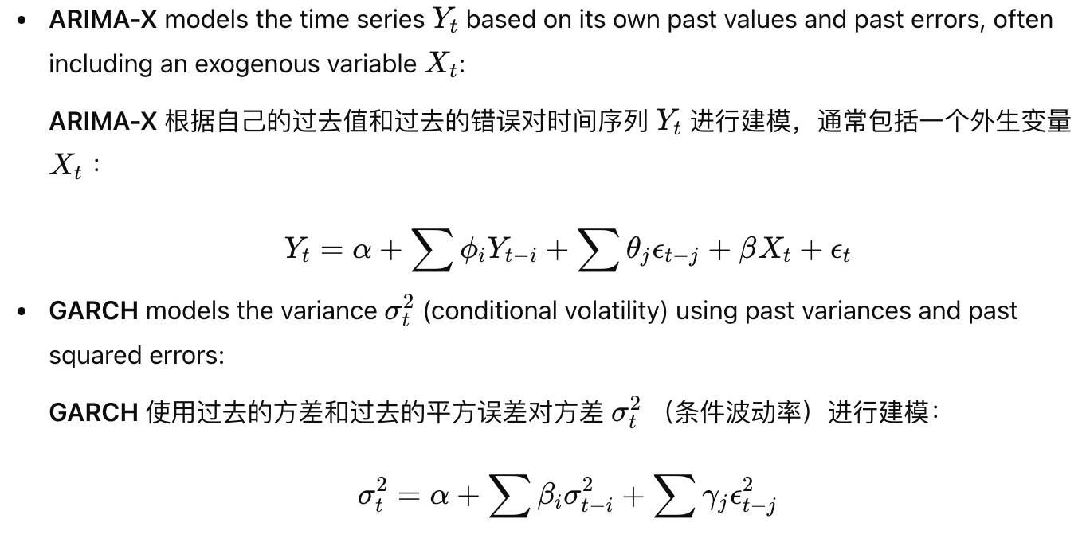

Conditional Dependence:条件依赖：ARIMA-X 根据过去的值和误差来设置平均值，而 GARCH 根据过去的方差和误差来设置波动性

Handling External Factors:处理外部因素：

**7.8 Economic intuition of GARCH in modelling volatility clustering and mean reversion**

Volatility Clustering: Large moves follow large moves, and small moves follow small moves, reflecting market uncertainty. GARCH models this by linking current volatility to past shocks.波动率聚类：动跟随动，小波动跟随小波动，反映了市场的不确定性。GARCH 通过将当前的波动性与过去的冲击联系起来来模拟这一点。

Mean Reversion: Volatility spikes return to average levels over time. GARCH achieves this by allowing the impact of past volatility to gradually decay.均值回归：波动率峰值随着时间的推移恢复到平均水平。GARCH 通过允许过去波动性的影响逐渐衰减来实现这一目标。

GARCH reflects how volatility clusters in the short term but reverts to a norm, matching market behavior.GARCH 反映了波动率在短期内如何聚集，但恢复到正常状态，与市场行为相匹配。

**7.9 Possibility of higher order GARCH models**

Possibility of higher-order GARCH models refers to the option of extending the basic GARCH(1,1) model to GARCH(p, q), where p and q are higher integers.高阶 GARCH 模型的可能性是指将基本 GARCH（1,1） 模型扩展到 GARCH（p， q） 的选项，其中 p 和 q 是更高的整数。